Word Reference
Program: to provide a computer with instructions for the completion of a task.
Algorithm: Step-by-step instructions describing how to achieve some result.

Distinction:
  - Algorithm – a step-by-step procedure, written in English, for a human to understand the process.
  - Program – a set of instructions written in a programming language for the computer to compute the required steps to provide results. In other words, a computer program implements algorithms.

Coding: transforming algorithms into a functional computer program

System Development Life Cycle Section
It describes the development process for an information system. Models of SDLC include.
waterfall, spiral, Agile software development, rapid prototyping, and incremental. SDLC has a big influence on creating a information system that handles applications

Systems Dev Life Cycle

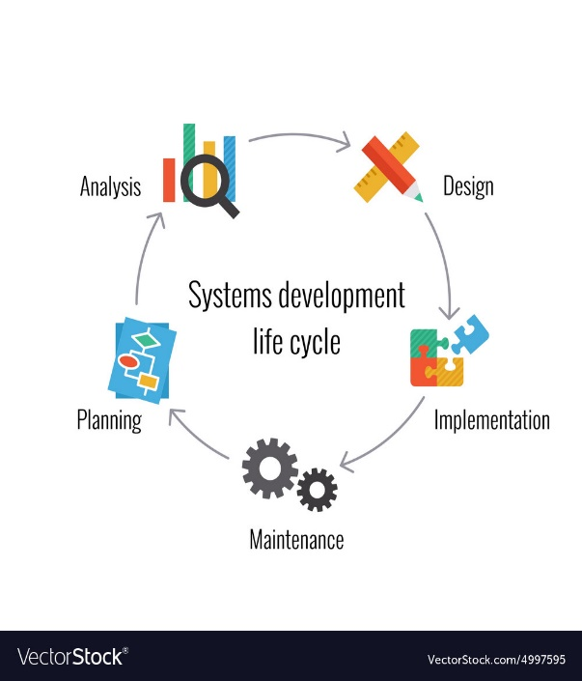

Word Reference
Design phase – system analyst will take note of inputs, processing and outputs for each program.
Implementation – programmers are tasked with writing programs as specified by systems analyst.
Maintenance phase – runs the previous phases and modifies programs until finished.
Applications
An information system or collection of programs that handles a major task.
Implementation
The phase of a Systems Development Life Cycle where the programmers would be assigned to write specific programs, where coding occurs as well as testing, additional features would be added per request during this phase.
Life cycle
Systems Development Life Cycle: Planning – Analysis – Design – Implementation – Maintenance
System analyst
Computer professional in charge of creating applications.
pseudocode
English statements used to convey the steps of an algorithm or function.
test data
Providing input values and predicting the outputs.

Program Design – made up of steps a programmer takes before they begin coding the program in a specific language. They commit to three areas.
Comprehending the program – documentation to help with understanding such as layouts, descriptions, etc. Understanding the Inputs, Processing and Outputs (IPO’s)
Use of design tools to make a model - diving the program into its functions, you would begin with utilizing pseudocode, documenting the logic or algorithm of each function. Methods of doing so include flow charting, structure charts, etc. Adapting to specified styles and guides at a business is critical. Understanding the logic and algorithm on sheets before coding is essential.
Developing test data – the input and output values entered in from programmer’s predictions.

Program Quality
Reliability – program has few errors.
Robustness – how well a program reacts due to errors and poor input.
Usability – the program runs its intended purpose.
Portability – can it be run on multiple programs / OS.
Maintainability – how well the program can be changed quickly.
Efficiency – how many of the system’s resources does it consumes to run.
Readability – how well a human can read and / or comprehend the why, flow and operation of source code.

Integrated Development Environment

An IDE is an application that aids comprehension. It contains course code editor, build automation tools, and debugger.

High-level-language – ASCII text source code file (mostly)

A Simple Programming Approach

- Cleary define result (OUTPUT)
- Determine what data is needed, and how to get it (INPUT)
- List the steps needed in between (PROCESS)

- Write your PLAN as pseudo-code and/ or flowchart.
- Test your plan for logical errors (DESK-CHECK)
- Get your dev environment ready (SET UP)
- Translate plan into code. (CODE)
- Attempt to run your program; find and fix syntax errors (DEBUG)
- Run your program using test data.
- Distribute

Flow Charting
Begins left -> right, top -> bottom.
Symbols

